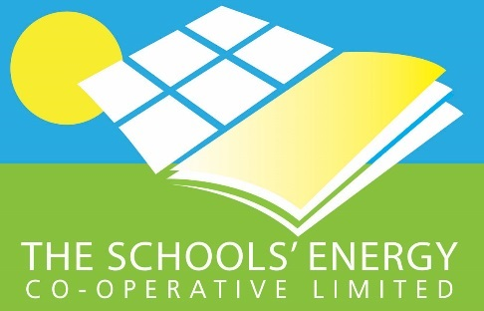
Press Release

COMMUNITY SHARE OFFER NOW OPEN

- Support an established social enterprise working to install solar panels on schools
- “Time is of the essence” before 18th September cut-off date

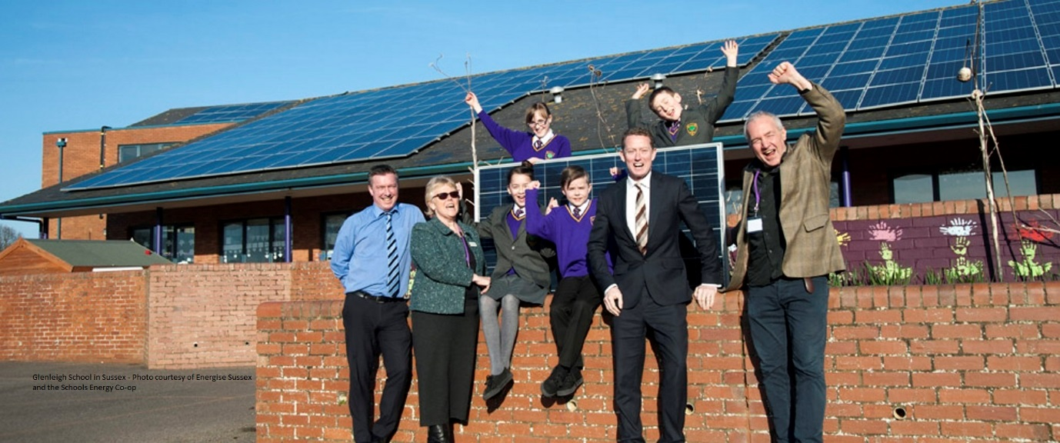
Glenleigh School, please credit Energise Sussex and The Schools Energy Co-op
The Sun is Shining – Help to make a greener future for our children
The Schools Energy Co-operative
COMMUNITY SHARE OFFER NOW OPEN

The Schools’ Energy Co-operative invites you to be a part of their established social enterprise, which has successfully installed community funded solar panels on 36 schools, throughout the UK. It is now issuing more shares to enable it to install solar panels on more schools.

The main aim of the project is to help reduce energy bills of the schools involved, enhance the education of our children, reduce climate change emissions and improve energy security.
We have six schools in the Ealing area which are set to have solar panels installed over the Summer holidays, and we may have more! You can be a part of this exciting initiative, and help schools in the area and others nationwide to educate future generations.
Andy Rolfe, one of the Directors and long-time Ealing resident, points out that the project has several benefits. “Benefitting the community is at the forefront of the project. Locally, the schools will save money on their energy bills and eventually will inherit the panels. Globally, the panels will reduce carbon emissions, helping to address climate change. You can purchase shares for as little as £100 and as a member you will also receive annual share interest, targeted to be 4.5%", starting from April 2019.”
The Society needs to raise £500,000 to complete the projects. The closing date for the scheme is 18th September 2018, therefore time is of the essence if you wish to be involved. This is an opportunity for local people to invest in their community and to play a part in a greener, more sustainable environment whilst raising awareness more generally about the importance of being energy efficient.

As a social enterprise, we are dedicated to supporting our schools and providing an alternative to the prevailing commercial schemes. Central to this is our aspiration to retain as much as possible of the benefits for the schools, their students and the surrounding communities. We also provide educational support to our schools and work with the schools and local community groups to maximise the environmental, educational and community impact of the solar installations.
Schools’ Energy Co-operative was established in August 2014 and installed its flagship 150kW array of solar panels at Glenleigh Park Primary Academy in Bexhill, East Sussex. This is still one of the largest community owned school solar systems in the country.
To download a copy of the Share Offer Document visit www.schools-energy-coop.co.uk
-Ends-

Editors Notes
For further information contact Lorraine Bilton, Marketing Co-ordinator, Energy4All.
Email: Lorraine@energy4all.co.uk Tel: 01229 821028. Or Laura Moreno Laura@energy4all.co.uk
Schools Website – www.schools-energy-coop.co.uk
Image Supplied – Glenleigh School, please credit Energise Sussex and The Schools Energy Co-op

